# Debugging Exercises

Name: Craig Lovell  
Campus: Sydney AIE Wentworth Park Campus

## Exercise 1: Run the Debugger

Run the Debugger Upload a screenshot of Visual Studio running in debug mode.  
Insert Screenshot

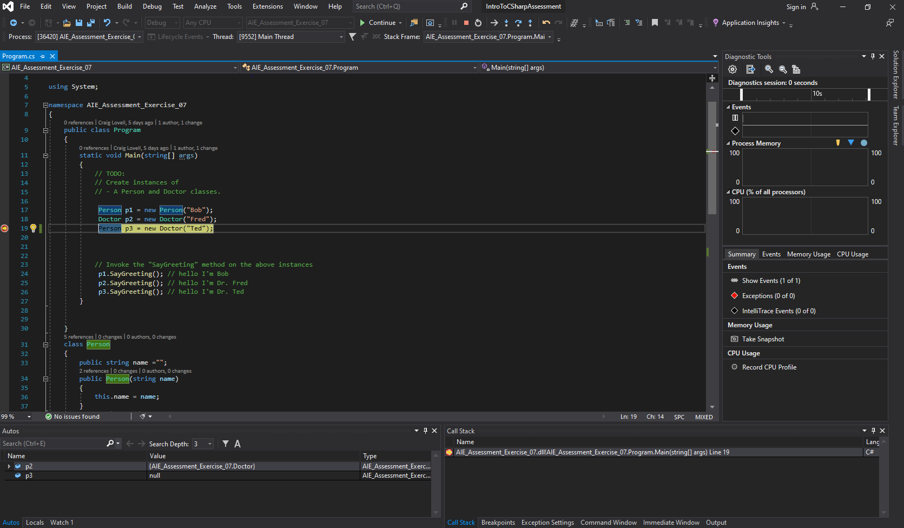

## Exercise 2: Compiler Errors

Upload a screenshot of 3 different compiler errors. Write a brief description of what each error means.

|  |  |
| --- | --- |
| **Screenshot** | **Error Description** |
|  | Missing ; causing a error  Fix by adding ; where the red line is to complete the line of code |
|  | Passing a number though a string which is never possible should mainly pass numbers though a int or a float and double  Fix remove string 2 as it isn’t needed there and is dummy code |
|  | Can not make draw virtual and abstract at the same time remove virtual to fix  This wouldn’t work as making it abstract makes the function / class not accessible from elsewhere |

## Exercise 3: Reference Material

List at least one website that provides material to aid you in understanding the C# Language.

<https://docs.microsoft.com/en-us/dotnet/csharp/>

## Exercise 4: Using the Debugger

Upload a screenshot showing.

* A breakpoint
* 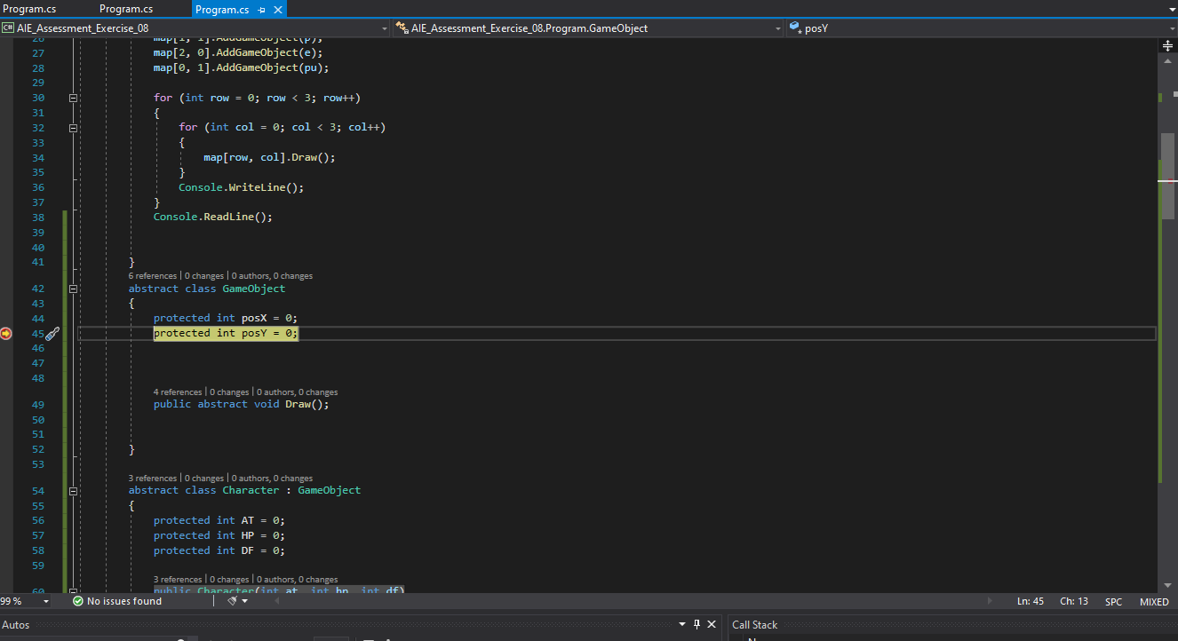
* A variable watch
* 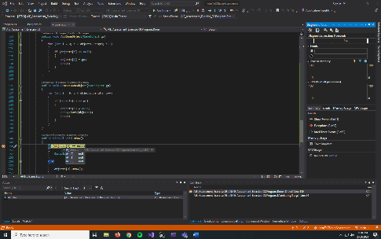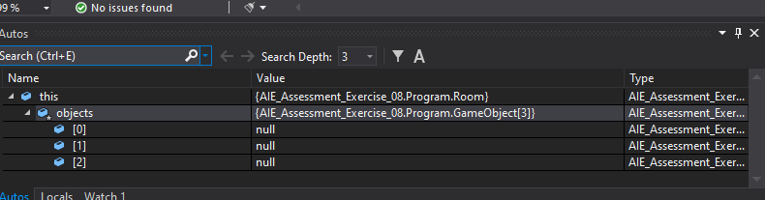
* The call stack
* 